Keith’s Primer on Program and Major Codes

Each major, minor and concentration must be assigned a 4-digit “major” code in STVMAJR. In the screen shot below, 0079 is assigned as “Business Administration” and the major and minor boxes are checked. This means it can be used to denote either a major or minor in business administration at any of the three campuses. You will notice that 0080 is Business Administration: Marketing and the Conc box is checked, which means it can be applied as a marketing concentration.

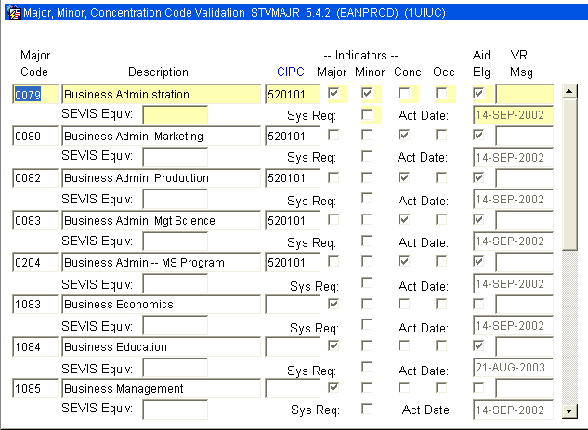

For some reason I don’t understand, you cannot check both the major and concentration box for a single record. In other words, you cannot have one four-digit code represent the major in history and a concentration in history. In this case, you would have a four-digit code for the history major and minor and a separate four-digit code for the history concentration.
Once the major codes are created, one can then bundle them into program codes. Let’s first look at a business administration with no concentration. In SOACURR, the Program Code 10KM0079BS is created which bundles the level 1U, campus 100, college KM, and degree BS. It also bundles the major code 0079, but on the “next block” (i.e., different screen). One can move to the majors block by clicking on the Majors button at the bottom of the screen.

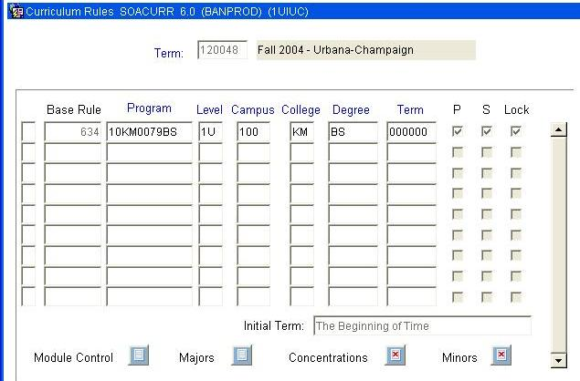

On the major block of SOACURR one can see that Major 0079 has been bundled into the program code 10KM0079BS. Therefore, 10KM0079BS is the shorthand code for a BS in Business Administration in the College of Business at Urbana.

Note that there is a red X through Concentrations button at the bottom of this page because there is no concentration associated with this program code.

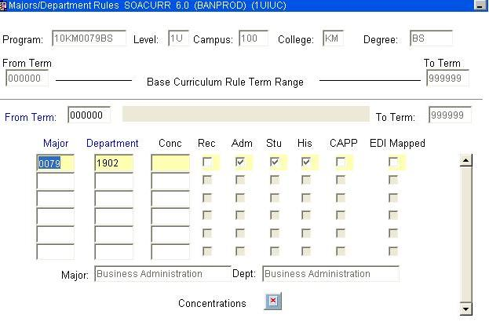
Now let’s look at the program code for a major in Business Administration with a concentration in Marketing. In SOACURR, the code 10KM0080BS is created. On the first block of SOACURR everything looks exactly the same except for the program code.

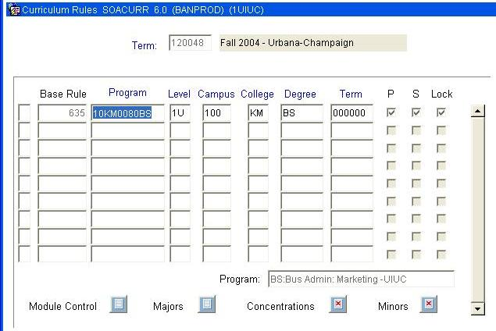
One the second block of SOACURR, we see the same major code 0079 but we now see 0080 (Marketing) in the concentration field. You’ll also notice that the Concentration button does not have a red X and is now clickable.

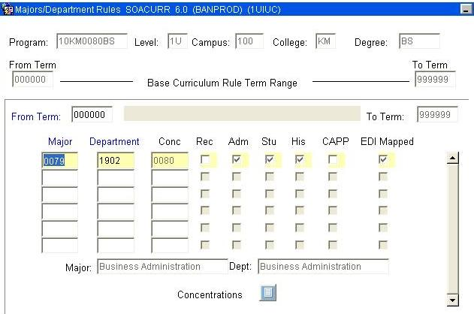
If you click the Concentration button you go to the third block of SOACURR which shows more detailed information on the concentration 0080.

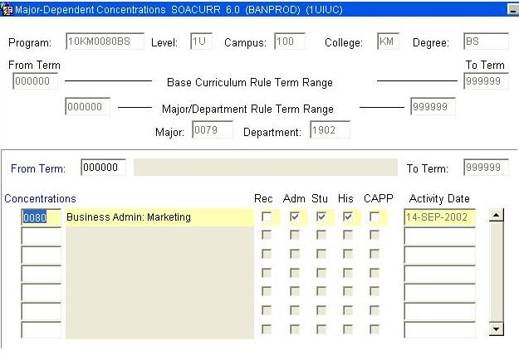

In summary, 10KM0079BS represents the BS in Business Administration (major code 0079) at Urbana while 10KM0080BS represents the BS in Business Administration (major code 0079) with a concentration in Marketing (major code 0080).
Let’s now look at how this translates into a student record. If one enters 10KM0079BS as the program code on SGASTDN it will populate the level, campus, college, degree and major.
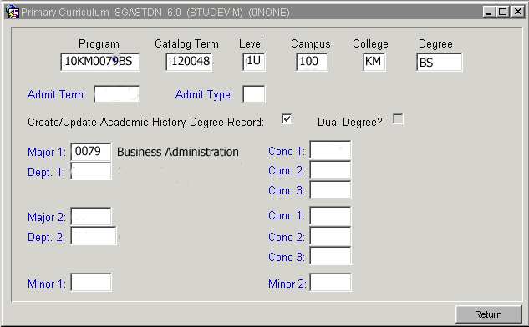

If one enters 10KM0080BS as the program code it populates the same values plus it defines the concentration. For some reason it does not automatically populate 0080 in the Conc 1 field, but it does limit the concentrations that can be entered to those approved for 0079.

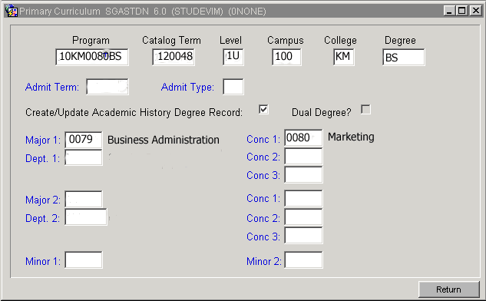
In both cases the Major remains 0079 because in both cases the students major is Business Administration. In order to realize that a student is pursuing a Business Administration major with a Marketing minor, one needs either the program code 10KM0080BS or the Major code 0079 and the concentration code 0080.

